**CRUD based Blog web application (“BlogScript”)**

**Project Synopsis**

SUMMER INTERNSHIP REPORT EVALUATION

BCASI23501

**BACHELOR OF COMPUTER APPLICATION**

|  |  |
| --- | --- |
| PROJECT GUIDE:  **MR. NITIN KUMAR SAINI**  **& MS. VARTIKA GUPTA** | SUBMITTED BY:  **PANKAJ KUMAR DAS (TCA2301489)**  **SEC: B** |

20 September 2025



**FACULTY OF ENGINEERING & COMPUTING SCIENCES**

**TEERTHANKER MAHAVEER UNIVERSITY, MORADABAD**

Table of Contents

1 Project Title 3

2 Domain 3

3 Problem Statement 3

4 Project Description 3

4.1 Scope of the Work 3

4.2 Project Modules 4

5. Implementation Methodology 5

6. Technologies to be used 6

7. Advantages of this Project 7

8. Future Scope and further enhancement of the Project 7

9. Team Details 8

10. Conclusion 8

11. References 8

12. Appendices 9

# Project Title

CRUD based Blog web application (“BlogScript”)

# Domain

Web development in PHP & MySQL

# Problem Statement

Creators often face difficulties in finding a minimal platform where they can quickly publish their ideas without distractions. They require a system where content ownership is secure, and posts can be managed anytime.  
**BlogScript** provides a solution by offering a **personal blogging space** where users can manage their profiles, write blogs, and update or delete them whenever needed. It focuses on **ease of use, content control, and secure authentication** for creators.

# Project Description

BlogScript is a CRUD-based web application designed for blogging enthusiasts who want a simple and user-friendly platform to share their ideas. The platform allows users to **sign up, log in, create, update, and delete blog posts** securely. It also provides a password reset feature to ensure account safety. With a clean UI and structured database, BlogScript focuses on making content creation smooth and accessible.

## Scope of the Work

The scope of this project involves building a **full-stack web application** using PHP and MySQL as backend technologies and HTML, CSS, and JavaScript for frontend development. The system includes:

* User registration and login system with password hashing
* Post creation, editing, and deletion
* Secure password reset via email verification
* Structured database design for users and posts

## Project Modules

1. **User Authentication Module**

* **Sign Up**: Allows new users to create an account with username, email, and password.
* **Login**: Provides secure access to the platform using email and password.
* **Email Verification**: Confirms the user’s email before account activation.
* **Password Reset / Update**: Enables users to reset or update their password securely via email.

1. **Blog Post Management Module**

* **Create Post**: Users can write and publish blogs.
* **Read Post**: Blogs are displayed on the homepage or dashboard.
* **Update Post**: Users can edit/update their previously created posts.
* **Delete Post**: Users can remove their posts from the platform.

1. **Email Integration Module**

* Sends verification emails during sign-up.
* Delivers password reset link to registered users.
* Sends notification emails (optional future scope).

1. **Database Management Module**

* Database schema includes users and posts tables.
* Handles CRUD operations for both users and posts.
* Ensures relational integrity between users and their posts.

1. **Security Module**

* Passwords are hashed using **PHP’s password_hash()** and **password_verify()**
* SQL Injection prevention using **prepared statements**.
* Secure session management and validation.

# 5. Implementation Methodology

**Step 1: Requirement Analysis**

* Identified core features: user authentication, blog post management, and email verification.
* Finalized technology stack: **PHP, MySQL, HTML, CSS, JavaScript, PHPMailer**.

**Step 2: System Design**

* Designed the **database schema** with users and posts tables.
* Designed responsive frontend layouts for signup, login, dashboard, and post pages.

**Step 3: Backend Development**

* Implemented **User Authentication** (signup, login, password hashing).
* Added **Email Verification** using **PHPMailer**.
* Developed CRUD operations for **posts** (create, read, update, delete).
* Implemented **password reset functionality** with email link.

**Step 4: Frontend Development**

* Built responsive UI using **HTML, CSS (custom + media queries), and JavaScript**.
* Integrated forms for login, signup, post creation, and update.

**Step 5: Integration**

* Integrated database queries with prepared statements for security.
* Linked PHPMailer for sending verification and reset emails.

**Step 6: Testing**

* Conducted **unit testing** for individual modules.
* Performed **integration testing** for login, signup, and post management.
* Tested the platform on different devices for **responsive design**.

**Step 7: Deployment & Future Scope**

* Deployed the project on **local XAMPP server** for testing.
* hosted on a **live server** with domain and SSL for real-world use.
* Future scope includes adding **admin dashboard, comments, and SEO optimization**.

# Technologies to be used

**1. Frontend Technologies**

* **HTML5** - For creating the structure and layout of web pages.
* **CSS3** - For styling, responsiveness, and UI design.
* **JavaScript (jQuery)** - For client-side validation, interactivity, and DOM manipulation.

**2. Backend Technologies**

* **PHP (Core PHP)** - For server-side scripting, handling requests, implementing business logic, and integrating with the database.
* **PHPMailer** - For sending verification and password reset emails using SMTP.

**3. Database**

* **MySQL** - To store and manage user accounts, authentication data, and blog posts.
* Tables used:
  + users (for user details, passwords, verification codes)
  + posts (for blog posts created by users)

**4. Server Environment**

* **XAMPP (Apache, MySQL, PHP, Perl)** → Used as the local development environment.
* **Apache Server** - To host and run the PHP application locally.

**5. Development Tools**

* **VS Code** - Code editor for writing and debugging code.
* **phpMyAdmin** - For managing MySQL databases.
* **Git/GitHub** (optional) - For version control and project collaboration.

**6. Other Supporting Tools**

* **Google Fonts (Poppins)** - For better typography.
* **Browser Developer Tools** - For testing responsiveness and debugging frontend issues.

**7. Hosting Server**

* **Infinity free** - For free hosting and testing server with SSL certificate and sub domain.

# Advantages of this Project

* Simple and user-friendly blogging platform.
* Secure login, signup, and password reset with hashing.
* Email verification to avoid fake accounts.
* Full blog management with **CRUD operations**.
* Responsive design for mobile and desktop.
* Easily scalable for future features.
* Database-driven and reliable storage.
* Practical for real-world blogging needs.
* Customizable for different users.
* Enhances full-stack development skills.

# Future Scope and further enhancement of the Project

* **Admin Dashboard** – To manage users, monitor posts, and remove inappropriate content.
* **Comments & Likes System** – For better engagement between readers and authors.
* **Categories & Tags** – To organize blogs and improve searchability.
* **Rich Text Editor** – To allow users to format text, add images, and embed media.
* **SEO Optimization** – For making blogs search engine–friendly.
* **User Profile Customization** – With profile pictures, bio, and social links.
* **Notification System** – Email or in-app alerts for new posts, likes, and comments.
* **Multi-language Support** – To make the platform usable for wider audiences.
* **Mobile App Integration** – Extending BlogScript as an Android/iOS application.
* **Cloud Hosting & Deployment** – For better performance, scalability, and global access.

# Team Details

| **Project Name** | **Course Name** | **Student ID** | **Student Name** | **Role** | **Signature** |
| --- | --- | --- | --- | --- | --- |
| CRUD based Blog web application (“BlogScript”) | Summer Internship Report  Evaluation  (BCASI23501) | TCA2301489 | Pankaj Kumar Das | Designing |  |
| Developer |
| Testing |
| Deployment |

# Conclusion

The **BlogScript Project** successfully provides a simple, user-friendly, and efficient platform for creating, managing, and sharing blogs. It enables users to post, update, and delete content easily while ensuring data security through authentication. The modular structure, responsive design, and use of modern web technologies make it scalable and adaptable for future enhancements.

# References

* **PHP Official Documentation** – <https://www.php.net/docs.php>
* **MySQL Official Documentation** – <https://dev.mysql.com/doc/>
* **W3Schools (HTML, CSS, PHP, MySQL Tutorials)** – <https://www.w3schools.com>
* **MDN Web Docs (HTML, CSS, JavaScript Guides)** – <https://developer.mozilla.org>
* **Stack Overflow Community Discussions** – <https://stackoverflow.com>
* **GeeksforGeeks (Web Development Resources)** – <https://www.geeksforgeeks.org>

# Appendices

s

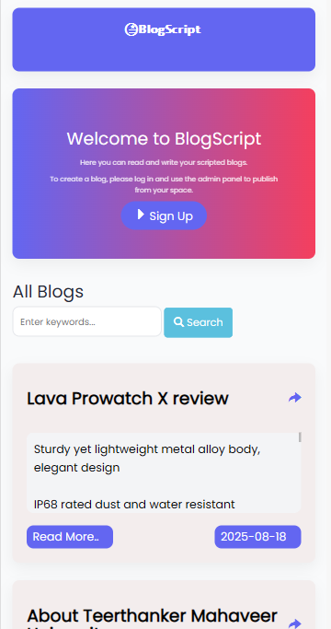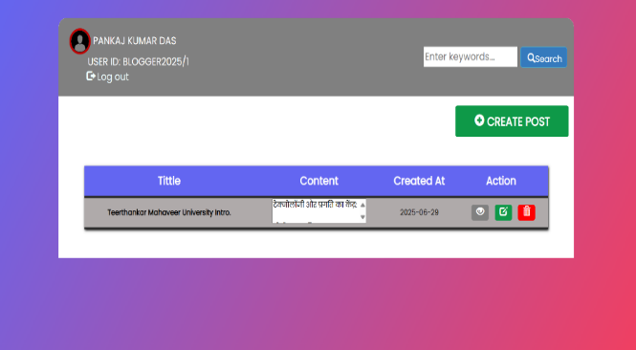



[https://blogscriptapp.free.nf/](%20https://blogscriptapp.free.nf/)